South Padre Spring Trip May 13-16, 2016

Total cost per person: $750
Payment Schedule- All money received is NON-REFUNDABLE
$187.50- due 12/4/15
$187.50- due 1/15/16
$187.50- due 2/18/16
$187.50-due 3/18/16
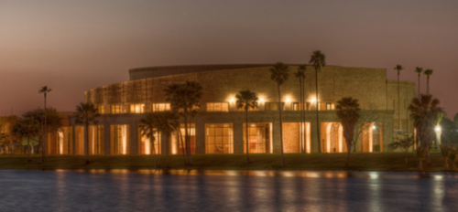

Students will the opportunity to perform at The Arts Center of TSC located in Brownsville Tx. They will also have fun at Schlitterbahn Water Park and at the Sea Ranch Marina before returning home that Monday. More details and an itinerary will be coming out at a later date. If you have any further questions, please email Mrs. James.

